**八部合音Pasibutbut**

**布農族是對歲時祭儀與生命禮俗文化特別講究的民族，也特別崇敬自然靈界，布農族人把祈望豐收的意念，以團體吟誦的方式來祈示，作為展現出布農族人與天地祖靈溝通。**

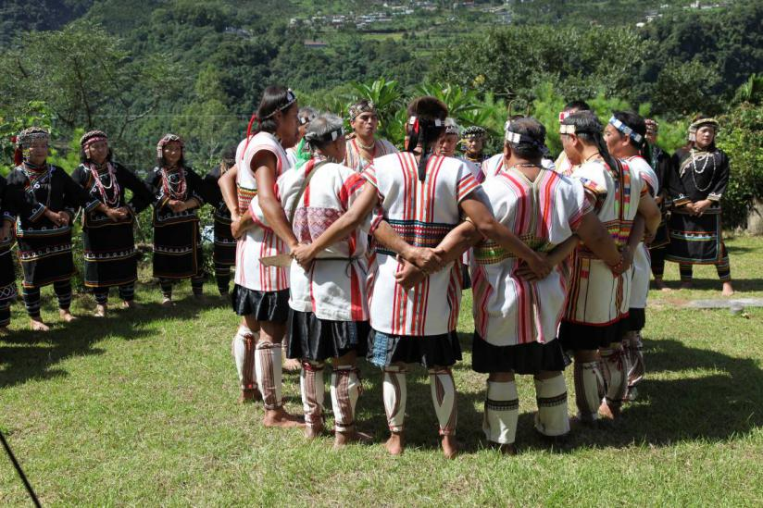

**Pasibutbut(祈禱小米豐收歌):它是用於傳統布農族曆的一月撒種祭（Minpinang）到三月間把耙祭（MANATU）其間所演唱的祭儀歌曲。一到了播種祭之前祭司決定祭日，此時祭司會慎選族中這一年之內所謂最聖潔的男士六至十名，住於祭屋之內。次日祭司帶領這些成年男子在屋外圍成圓圈，雙手交叉置於背後，圈內放置種栗一串。此時在祭司的領唱之下，先在屋外演唱這首「祈禱小米豐收歌」，然後慢慢移入屋內，象徵今年播種的小米能豐收，並堆滿穀倉。由於這首祭儀歌曲的演唱形式之特殊性及其與整個祭儀結合的複雜性，這首「祈禱小米豐收歌」早已斐聲國際，中外皆知。從音樂的結構觀之，演唱的聲部最多只有三部形成的覆音現象。只是唱這首曲子時，必須要八名男子以上分成「MAHOSGNAS」、「MANDA」、「MABONBON」、「LAGISGNIS」等四個聲部，再依一套嚴謹的規則慢慢依次進入合唱。由於每一位歌者的音質迥異，因此八部合音的錯覺現象於焉產生。無論如何Pasibutbut已是一首中外皆知，並且最具特色的布農族傳統歌謠。**

Pasibutbut (“Prayer for a Bountiful Harvest”)

Pasibutbut is a ceremonial song sung between January on the Bunun traditional calendar and the planting ceremony (minpinang) and March on the Bunun traditional calendar and the tilling of fields ceremony (manatu). It is a song of worship to the earth. Just before the planting ceremony, the village shaman will carefully select six to ten worthy men, who will stay in a special ceremonial hut. At the appropriate time, the shaman will lead these men to form a circle outside the hut. They will cross their arms across each other’s backs and sing Pasibutbut, slowly moving back into the hut, symbolizing that the millet that has been planted will result in a plentiful harvest filling the storage huts. This song is already well known in musical theory circles in Taiwan and abroad. The Bunun tribe calls it an eight-part chorus, but from a musical theory perspective there are only three parts. However, to be sung properly there must be at least eight men performing four parts, referred to as Mahosgnas, Manda, Mabonbon and Lagisgnis. There is a very strict set of rules for when each part is sung, and each singer must have a different tone quality, which makes it sound like there are eight parts. Pasibutbut is the most representative of the Bunun traditional songs.